O&M Billing Module:

User Manual



M.P. STATE ELECTRONICS DEVELOPMENT CORPORATION LTD.
State IT Centre, 47-A, Arera Hills, Bhopal-462011 (M.P.)
www.mpsedc.mp.gov.in

Project: Jal Rekha Water Management System
Module: O&M Billing (Operation & Maintenance Billing)
Sub-Module: O&M Billing Details
Document Version: 1.0
Date: December 2025
Organization: Madhya Pradesh Jal Nigam Department

Table of Contents
1. Introduction 3
1.1 Purpose 3
1.2 Target Users 3
2. Access and Navigation 4
3. GM – O&M Billing 4
3.1 GM Dashboard 4
3.2 Key Features (including CR changes) 4
3.3 GM Bill Creation – Step by Step 5
4. Contractor – O&M Billing 5
4.1 Contractor Dashboard 5
4.2 Key Features & CR Enhancements 5
4.3 Contractor Bill Entry – Step by Step 6
5. O&M Billing Reports 7
5.1 Report Types 7
5.2 Common Filters 7
5.3 Export 7
6. Validations and Error Messages 7
7. Roles and Approval Workflow 8
8. Best Practices for Users 8
9. Screenshots refer - Jal Rekha Module PPT 03-Jan-2026_V_1.5 8
9
Document Revision History 10

1. Introduction
The O&M Billing module of Jal Rekha supports preparation, verification, and approval of Operations & Maintenance bills for each scheme and PIU.
It ensures that GM PIU and Contractor users can calculate bills correctly based on CPI, penalties, additional facilities and service-level parameters.

1.1 Purpose
- Guide GM PIU and Contractor users to raise, edit, verify and approve O&M bills.
- Explain validations, reports and common error scenarios.
- Provide reference for new CR functionality implemented in O&M Billing.

1.2 Target Users
- GM PIU (O&M)
- Contractor (O&M Billing)
- Department Users (Monitoring / Reports)
- Application Support Team

2. Access and Navigation
- Login to Jal Rekha with your user ID and password.
- From the main menu, choose: Jal Rekha → O&M Billing.
- Sub-modules (links) typically visible:
  - GM – O&M Billing
  - Contractor – O&M Billing
  - O&M Billing Reports
  - Bulk Reports / MWSR / Dhara Reports (if enabled)

3. GM – O&M Billing

3.1 GM Dashboard
- Shows list of Schemes / PIUs mapped to the GM.
- Columns: Scheme Name, PIU, Agreement Value, Month–Year, Bill Status (Draft / Submitted / Approved / Rejected).
Actions available:
- Create / open bill for selected month.
- View Contractor-submitted data.
- Apply validations and approvals.

3.2 Key Features (including CR changes)
- 24 PIUs data visible to Kapil (GM PIU O&M) ID
  - GM’s consolidated admin ID “GM PIU O&M” can view saved and submitted data of all mapped PIUs after save & submit.
- Kapil ID rename
  - Label changed from Kapil to “GM PIU O&M” in all screens and reports.
- Unique village mapping
  - For one village, multiple time mapping is not allowed.
  - System shows validation message if same village is selected again for the same scheme/month.
- Correct GM PIU and Contractor name display
  - Names appear as per master data on all bill and report pages.
- Agreement value and field persistence
  - Agreement value column and data are fetched correctly from master.
  - Data entered in Additional Facilities and other tabs does not change after logout–login; values are persisted.
- Scheme change and data refresh
  - When scheme is changed, old scheme data is cleared and fresh data is loaded (similar to logout refresh behaviour).

3.3 GM Bill Creation – Step by Step
- Open GM – O&M Billing.
- Select Scheme, Month–Year and click Open Bill.
- Review pre-fetched data (meter readings, CPI, penalties, additional facilities, power consumption etc.).
- Enter / update:
  - Agreement Value (if editable)
  - Additional Facilities and related CPI increments
  - Other scheme-specific parameters
- Click Save to keep in Draft.
- After verification, click Submit to Contractor / Department as per workflow.
- If returns with observations, modify and resubmit.

4. Contractor – O&M Billing

4.1 Contractor Dashboard
- Shows list of schemes assigned to the contractor with current billing month and bill status.
- Access to Billing, Penalty / Relaxation, Additional Facilities, and Upload Documents tabs.

4.2 Key Features & CR Enhancements
- Billing calculations
  - CPI base year and month are applied instantly on selection.
  - Billing amount is auto-calculated based on agreement value, CPI and penalties.
- Report column updates
  - Column “No of HSC” replaced by “Additional affected HSCs” in relevant reports.
  - Remarks column appears at the end of the report as required.
- Complaint handling
  - Complaint Resolved Date label corrected to “Resolved”.
  - Complaint Type text corrected to:
“Demand that cannot be fulfilled as per the agreement”.
- 48-hour event edit rule
  - Events before 48 hours cannot be edited and do not increase count.
  - Events after 48 hours follow normal counting rules.
- Penalty Relaxation
  - Field Reason for relaxation becomes mandatory only when Relaxation = YES.
  - Spelling for Penalty Relaxation corrected across screens.
- Document uploads
  - Power Consumption: user uploads single PDF containing electricity bills of Intake, IPS, WTP.
  - Sub-Meter Reading Proof: additional label “Upload supporting doc (Sub Meter Reading Proof)” available.
  - Documents shown in related reports.
- Additional Facilities validations
  - CPI increments displayed in Manpower penalty column.
  - After saving entries for Manpower, Vehicle, Other sections they become non-editable (freeze).
  - Validation: No. of Mobile ≤ No. of Manpower.
- Bulk reports / integration
  - Bulk User MWSR / Dhara reports implemented and linked with O&M Billing where applicable.
  - New functions and pages created on database side for these reports.

4.3 Contractor Bill Entry – Step by Step
- Open Contractor – O&M Billing.
- Select Scheme, Month–Year and click Create / Edit Bill.
- Fill or verify:
  - CPI base year & month
  - Service level parameters and penalties
  - Additional facilities (manpower, vehicle, others)
  - Complaint and resolution details
- Upload required documents:
  - Electricity bill PDF
  - Sub-meter reading proofs
  - Any other supporting PDFs.
- Validate errors (red messages) and correct.
- Click Save to keep as Draft; click Submit to GM for review and approval.

5. O&M Billing Reports

5.1 Report Types
Typical reports include:
- GM O&M Billing Summary Report – scheme-wise/month-wise bills with status.
- Contractor Billing Detail Report – detailed calculations and CPI/penalty components.
- Penalty & Relaxation Report – list of all penalties and relaxations with reasons.
- Document Status Report – shows availability of required uploads for each bill.
- Bulk User MWSR / Dhara Reports – integrated consumption and service reports linked to billing.

5.2 Common Filters
- Financial Year, Month, Scheme, PIU, Contractor, Bill Status (Draft / Submitted / Approved / Rejected).

5.3 Export
- Use Export to Excel / PDF buttons at top-right (if enabled) for sharing and audit.

6. Validations and Error Messages
Examples of important validations:
- Duplicate village mapping – “For selected village, mapping already exists for this scheme/month.”
- Agreement value missing – “Agreement value is mandatory for billing.”
- Missing documents – “Upload electricity bills (single PDF) before submission.”
- Mobile vs Manpower – “No of Mobile should be less than or equal to No of Manpower.”
- 48-hour rule – “Events before 48 hours cannot be edited.”
Users must correct the highlighted field(s) and click Save again.

7. Roles and Approval Workflow
- Contractor creates / edits bill and submits to GM PIU O&M.
- GM PIU O&M verifies data, applies corrections and either Approves or Rejects with remarks.
- Approved bills are available in Department Reports and downstream financial systems (if integrated).
Status values typically used: Draft → Submitted → Approved / Rejected.

8. Best Practices for Users
- Complete all mandatory fields before submission to avoid rework.
- Ensure documents are scanned clearly and combined into required single PDFs.
- Avoid last-minute submissions; system validations or network issues may delay approval.
- For any configuration or master-data issues (wrong agreement value, scheme not visible), contact application support / master data team rather than adjusting bill values manually.

- Screenshots
refer - Jal Rekha Module PPT 03-Jan-2026_V_1.5

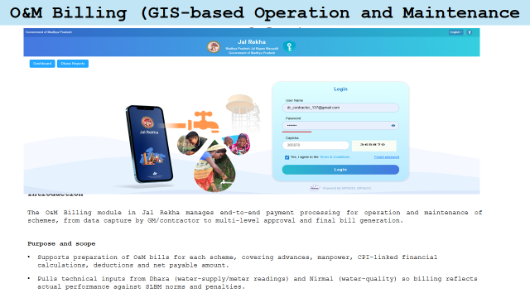
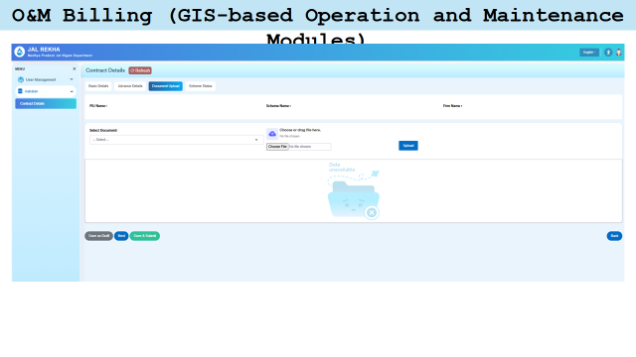

Document Revision History
Version | Date | Author | Changes
1.0 | Dec 2025 | Jal Rekha PMO | Initial user manual creation

Copyright © 2025 Madhya Pradesh Jal Nigam Department
Designed, Developed and Maintained by MPSSDI MPSeDC
Document Classification: Standard User Documentation
Last Updated: December 2025

